MARKFED CANNERIES, VILLAGE CHUHARWALI DISTT. JALANDHAR
TERMS & CONDITIONS FOR e-TENDER FOR PURCHASE OF PET BOTTLES, PET JARS AND GLASS BOTTLES.
E-TENDER No. MCJ/2025-26/13
Markfed Canneries, Village Chuharwali, Tehsil, Adampur, Distt. Jalandhar (A unit of The Punjab State Cooperative Supply & Marketing Federation Limited) regarded as Asia’s one of the largest marketing cooperative institution in the agro food sector. Markfed Canneries is going to purchase of Pet Bottles, Jars and Glass bottles Food Grade as per detail given below. Quantity can be increased or decreased as per our actual requirements as per orders received. The Tender shall be opened as per schedule given below in the office of Manager Markfed Canneries, Village: Chuharwali, Tehsil: Adampur, Distt.:Jalandhar. In case of holiday the tender shall be opened on next working day without giving any further notice. Complete tender including earnest money shall be accepted online only. No other mode shall be accepted. The tender shall be opened in the presence of bidders, who may wish to be present. For participating in the tender, the parties shall have to get themselves registered with http://eproc.punjab.gov.in and get the user ID, password and Class 3 Digital Signatures.
Sr.  No. | Name of the items. | Tender  Form Fee | processing  Fee | Earnest  Money
1. | Purchase of Food Grade Pet Bottles, Pet Jars and Glass bottles.  The rates should be quoted F.O.R.  Markfed Canneries, Village:Chuharwali,  Tehsil : Adampur, Distt.: Jalandhar and  GST extra as applicable shall be paid extra. | Rs 590/-  (Inclusive  of GST) | As per  E-Tender Website | 20,000/-
Contd.2

-2-
Schedule Time
Items on  Sr. no. | Contract Period | Last date & time  For submission  Of online Tender. | Date & time For opening  Of Technical Bid.
1. | 1 Year | 06.01.2025  up to 02:00 pm. | 07.01.2025  at 11:00 am

Delivery schedule shall be supplied to the successful bidder as per our actual requirements.
The tender shall be received as per two bid system i.e. TECHNICAL BID & FINANCIAL BID.
Technical bid shall be opened first to evaluate the eligibility by the committee. The Financial bid shall be opened only of those parties who shall be successfully qualified in the technical bid. The tenderer who shall not qualify in the technical bid his tender will be out rightly rejected.
1. NAME OF THE BOTTLES AND TENTATIVE QUANTITY
Sr. No. ITEM QUANTITY(Tentative)
- Pet Bottle 1kg for Honey
(For Packing of 1kg Honey) 20,000 Nos.
- Pet Bottle 500gm for Honey
(For Packing of 500gm Honey) 20,000 Nos
- Pet Bottle 250gm for Honey
(For Packing of 250gm Honey) 20,000 Nos
- Pet Bottle 250 gm squeeze for Honey
(For Packing of 250gm Honey squeeze bottle) 5,000 Nos.
- Pet Bottle for Vinegar 750ml
(For packing of 750ml vinegar) 10,000 Nos.
- Pet bottle for Gulab Sharbat 750ml
(For packing of 750ml Gulab sharbat) 15,000 Nos.
- Pet jar for Shakkar and Gur
(For packing of 900gm Gur and Shakkar) 5,000 Nos
- Tomato Ketchup food grade Glass Bottles 930ml.
Crown Cork Bottles.
(For Packing of 1kg Tomato Ketchup) 25,000 Nos.
- Tomato Ketchup food grade Glass Bottles 450ml.
Crown Cork Bottles.
(For Packing of 500g Tomato Ketchup) 5,000 Nos.
- Jam food grade Glass Bottles 400ml, Round 63mm Lug.
(For Packing of Jam 500gm.) 5,000 Nos

Note : Quantity can be increase or decrease as per actual requirements.

Contd.:3

-3-
2. SPECIFICATIONS AND DIMENSIONS OF FOOD GRADE PET BOTTLES AND JARS :-
- Pet Bottle 1kg for Honey
(For Packing of 1kg Honey)
Weight: : 55 gm + 2%.
Weight of Cap : 10.50gm + 1gm.
Color of Caps : Orange with SOHNA printed on top.
Neck size : 83mm

- Pet Bottle 500gm for Honey
(For Packing of 500gm Honey)
Weight: : 32 gm + 1%.
Weight of Cap : 7gm + 0.5gm.
Color of Caps : Orange with SOHNA printed on top.
Neck size : 63mm

- Pet Bottle 250gm for Honey
(For Packing of 250gm Honey)
Weight: : 26 gm + 1%.
Weight of Cap : 5gm + 0.5gm.
Color of Caps : Orange with SOHNA printed on top.
Neck size : 53mm

- Pet Bottle 250gm for Honey Squeezy
(For Packing of 250gm Honey)
Specification as per annexure (A)attached.

Contd.:4

-4-
- Food Grade Pet Jars for filling of 900gm Shakkar and Gur.
Weight of Jar : 50gm + 2gm.
Weight of Cap : 12gm + 1.50gm.
Color of Caps : Red cap with Handle.
Neck size : 83mm
- Food Grade Pet Bottles for filling of 750ml Gulab Sharbat.
Weight of Jar : 45gm + 1gm.
Volume : 750ml.
Neck size : 45mm (outer dia with thread)
- Food Grade Pet Bottles for filling of 750ml Vinegar.
Weight of Jar : 28gm + 1gm.
Volume : 750ml.
Neck size : 28mm (outer dia with thread)

- Tomato Ketchup food grade Glass Bottles 930Ml Crown Cork Bottles.
(For Packing of 1kg Tomato Ketchup)
Weight: 510 + 15 gm.
Brimful Capacity: 916 + 10 ml.
Body Diameter: 84 + 1.50 mm.
Base Diameter: 79 + 1.50 mm.
Height of Bottle: 283.50 + 1.5 mm.
Height below slanting: 164mm.

- Tomato Ketchup food grade Glass Bottles 450Ml Crown Cork Bottles.
(For Packing of 500g Tomato Ketchup)
Weight: 248 + 12 gm.
Brimful Capacity: 450 + 4 ml.
Body Diameter: 66.25 + 1.50 mm.
Base Diameter: 63 + 1.50 mm.
Height of Bottle: 218.50 + 1.5 mm.
Height below slanting: 110.50mm.

- Jam food grade Glass Bottles 400ml,Round 63mm Lug
(For Packing of Jam 500gm.)
Weight: 155 + 12 gm.
Brimful Capacity: 400 + 6 ml.
Base Diameter: 70.80 + 1.50 mm.
Mouth Diameter: 62.05 + 0.45 mm./58.90 + 0.45 mm.
Height of Bottle: 129 + 1.50 mm.

Note : Design of bottles/jars can be seen in Markfed Canneries, vill. Chuharwali, Distt. Jalandhar on any working day between 9am to 5pm.

Contd.:5

-5-
3.RATE:- Rates will be quoted per Bottle and per Jar, F.O.R. Markfed Canneries, Village: Chuharwali, Tehsil: Adampur, Distt.:Jalandhar and GST (as applicable) will be paid extra, if any.
4. EARNEST MONEY: The earnest money of Rs.20,000/- should be deposited online only. No other mode shall be accepted. Tenders without earnest money are liable to be rejected.
5. DELIVERY SCHEDULE: Supplies will be made strictly as per delivery schedule given by Markfed in the purchase order as per actual requirements from time to time. Delivery schedule can also be changed by Markfed at any time as per our actual requirement. In case the supplier fails to supply the material as per delivery schedule of 15 days, the penalty @ 1% of purchase value shall be imposed on the supplier for delay of fortnight for maximum of 15 days. In case the supplier fails to supply the material within penalty period as enumerated above, the contract shall be terminated and supplier shall be blacklisted. However the material shall be purchased from the open market at the risk and cost of the supplier and Security amount deposited by the supplier will be forfeited. However, MD ,Markfed reserve the right to condone the penalty in case the circumstances were beyond the control of the supplier.
The Tender/order Quantity Mention is tentative as such can be increased or decreased as per our actual requirements without any condition.
The counting of Bottles and Jars shall be done in Markfed Canneries premises in the presence of supplier, if present.

6. INSPECTION/TESTING OF BOTTLES AND JARS:
Samples will be drawn from each and every consignment by the committee constituted by Markfed in the presence of the representative of the supplier/party, if present and will sent to the Markfed Testing Lab. Mohali for testing and test will be conducted by Markfed Lab. under the procedure/method in vogue. Results so conveyed by the Markfed lab. will be binding on both the parties. Markfed reserve the right to get all the tests/any other test which may Markfed may deem necessary from the reputed/accredited Laboratory at the cost of the supplier. In case the quality of the bottles are not found as per specifications and will be rejected. The supplier has to lift back the same within 7 days at their own risk & cost. In case of failure to lift the same within 7 days, the storage charges @ 0.25 paise per bottle of per day for maximum up to 15 days will be charge from supplier. Afterward the rejected stocks will be disposed off at the risk & cost of the supplier. Markfed will also forfeit the security amount deposited by the supplier and material will be purchased at the risk & cost of the supplier from open market. The expenses related to inspection and testing shall be borne by the supplier.

Contd.:6
-6-

7. PAYMENT CONDITIONS:
Payment will be made through R.T.G.S. only within thirty days of receipt of each consignment subject to satisfactory inspection report. Supplier should provide complete bank details along with bank account no., I.F.S.C. code etc. Supplier should also provide self attested copies of GST no. and Pan no.

8. SECURITY:
The successful tenderer shall have to deposit Security equal to 5% of contract awarded or Maximum of Rs. 50,000/- (Rs. Fifty thousand only), as security in the shape of bank draft in favour of Markfed Canneries, Village Churharwali, Jalandhar, payable at Jalandhar within seven days of acceptance of offer which will be released on completion of contract. No interest shall be paid on EMD/ Security. The earnest money of Rs.20,000/- can be adjusted by the successful tenderer while depositing the security. This security amount shall be liable to be forfeited in case of non-execution of this contract.

9. RISK PURCHASE:
In the event of failure to supply the goods as per our specifications or as per our given delivery schedule, Markfed reserve the right to purchase the goods/material from the open market at the risk and cost of the supplier with due notice and security amount deposited by the supplier shall be forfeited and supplier shall be blacklisted for a period of two years.

10. Minimum Turnover :
Proof of minimum annual Turnover of Rs. 1.00 Crore duly attested by CA from one of the last three years. (UDIN generated).Bidder shall also submit scanned copies of two years out of last three years income tax returns.
11. VALIDITY OF OFFER:
This tender will be valid for 60 days from the date of opening of tender and period of contract is one year from the issue of award letter. Markfed reserve the right to extend this contract for another three months on the same rates and term & conditions, for which the supplier shall have no objection.

Contd.:7

-7-

12. OTHER CONDITIONS:
The tenderer shall sign on all the pages of these terms & conditions in view of having acceptance of the same and the successful tenderer shall submitted the hard copy in the office of Manager Markfed Canneries, Chuharwali, Tehsil Adampur, Distt. Jalandhar.
The tenderer shall also give his complete postal address with seal and mobile no. and email address.
The successful tenderer shall execute an agreement with Markfed Canneries on non-judicial Stamp Paper.
The violation of any terms & conditions of this contract shall result in the forfeiture of security and payable bills of the supplier and the supplier shall be black listed for two years. Markfed reserve the rights to purchase the material at the risk and cost of the supplier and security deposited by the supplier shall be forfeited.
Conditional tenders shall not be considered.
If the date of opening of tender happens to be holiday then the tender will be opened on the next working day without giving any separate notice.
Corrigendum/addendum/corrections if any will be published on the website.
Markfed will not be responsible if the tenderer/vender is unable to upload/submit the tender online due to any fault or malfunctioning of the internet/e-tender site.
Markfed reserves the right to accept/reject any or all tenders without assigning reasons.
The tender form fee, E.M.D. and processing fee should be deposited online/E-payment mode
only. No other mode will be accepted.
The supplier must bring along with original documents for inspection by the tender opening committee. In case of any non-production of original documents, the tender of the party will be rejected.
During screening and even later on and at any stage, if documents of any firm are found to be fake / forged, the firm will be black listed for two years for participation in any of the tenders invited by Markfed and the stocks will be purchased at the risk & cost of the supplier and security amount deposited by the supplier shall be forfeited.
The Party will submit attested copies of following documents online and the attested copies of these documents should be submitted by successful tenderer on the demand of the committee for verification of the original documents of the successful tenderer.
The supplier must bring along with original documents for inspection by the tender opening committee. In case of any non-production of original documents, the tender of the party will be rejected.

Contd.:8

-8-

13. GST Clause:
The party will raise invoices for the products supplied to Markfed including GST, on F.O.R. basis at Markfed Canneries, Jalandhar. All Govt. taxes/levies as applicable would be deducted from the payment. Markfed reserve the right to release the payment of GST mentioned in the supply invoices only post matching of the invoices in the GSTIN system. This shall be ensured by the supplier that the invoice raised by him during a month is approximately reported in the GST returns of the said month. The party shall ensure that the invoice to be raised with Markfed is complete with the provisions of the GST Law and contains the requisite details in an accurate manner for claiming ITC by Markfed.
Markfed reserve the right to claim from the party any amount of tax, interest, penality and litigation cost, if any, that may be incurred/accrue in future due to GST reporting/compliance mistake(s) on part of the party.

14. TDS/any other taxes will be deducted by Markfed as per applicable rates according to statutory provisions

15. ARBITRATION CLAUSE:
All the disputes and differences arising out of or in any manner touching or concerning the agreement whatsoever, shall be referred to the sole arbitration of an arbitrator to be appointed by the SPA/Markfed from the panel of the independent Arbitrators. The second party will have no objection to the appointment of the arbitrator from the panel of the independent Arbitrator maintained by SPA/Markfed, which is in consonance with the 7th schedule of the Arbitrators & conciliation Act, 1996. The award of the arbitrator shall be final and binding on the parties to the contract. In the event of death of an Arbitrator or his being transferred or vacating his office or being unable to act for any reasons, the SPA/Markfed concerned at the time of such transfer, vacation of office, death or inability, shall appoint another person to act as Arbitrator. Subject as aforesaid, the arbitration & conciliation Act, 1996 (as amended in 2015) or any statutory re-enactment or modifications thereof shall apply to the arbitration provided under this clause. The fee of the Arbitrator so appointed shall be governed by the terms and conditions of the Markfed.
I/we have read and understood all the Terms & conditions of the bid and all the Terms & conditions are accepted to me/us. I shall abide by the same.
Signature ______________
Name and address of the party with Stamp _________________

Annexure-A

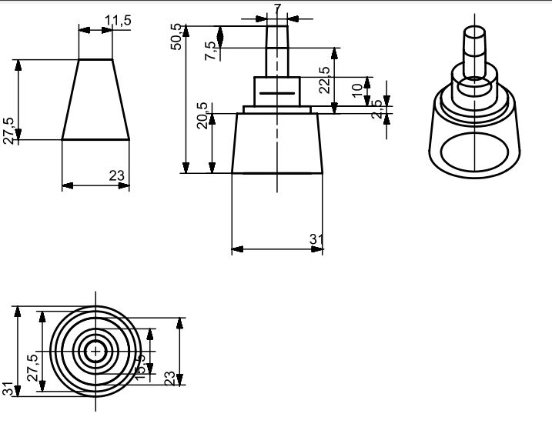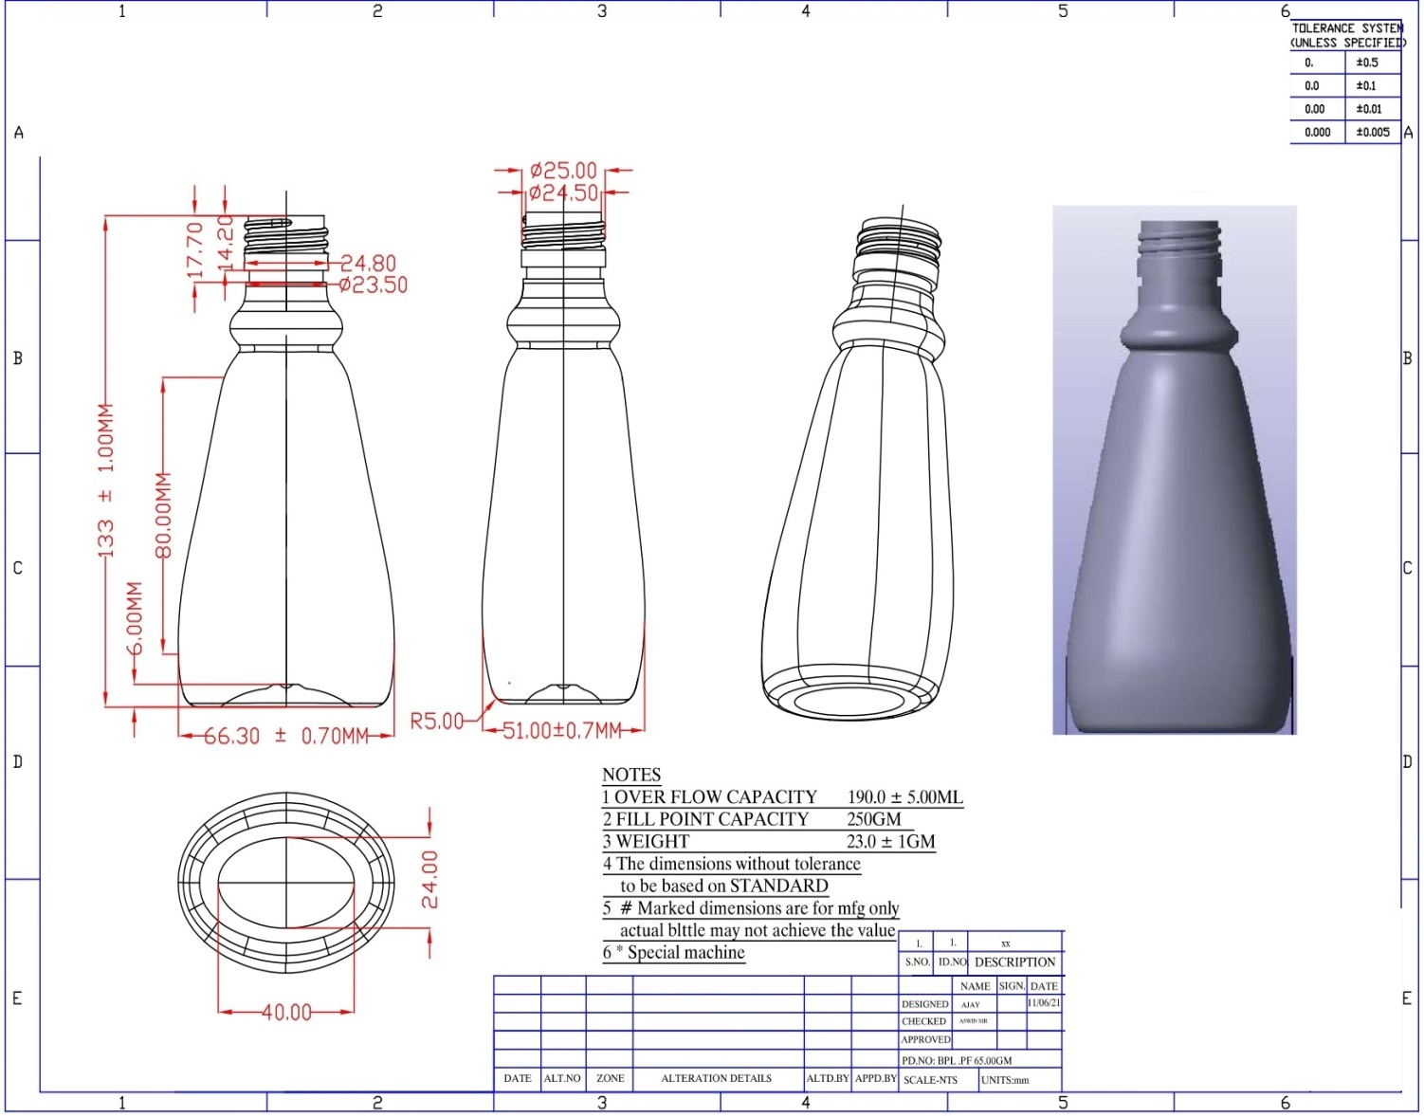

MARKFED CANNERIES, VILLAGE CHUHARWALI DISTT. JALANDHAR
TECHNICAL BID
E-Tender Notice No. MCJ/2025-26/13
FOR PURCHASE OF PET BOTTLES AND GLASS BOTTLES
CONTRACT FOR THE PERIOD OF ONE YEAR.
Sr.No. | Particulars | Remarks
1. | Name and complete address of the firm with mobile no, Attach attested copy of PAN & GST No | Attach proof.
2. | Detail of Earnest Money Deposited. | Attach proof.
3. | Attach scanned copy of Terms & Conditions of Tender duly signed by the bidder on all pages. | Attach copy.
4. | Name and Proof of the Bank account. | Attach proof.
5. | Proof of minimum Turnover of Rs. 1.00 Crore duly attested by CA from one of the last three years. | Attach Copy.
6. | Power of attorney in favour of the authorized person to sign the tender documents. | Attach copy.
7. | An undertaking on the letter head of the bidder stating that party has no dispute with Markfed/State Govt./Central Govt. | Attach copy.

Signature ____________________________
Name and address of the party with Stamp ____________________________
____________________________
____________________________
Ph./Mobile No ____________________________
Email Address: ____________________________

I/c Lab. I/c G.Store I/c Prod.(HP) I/c Prod. I/c Purch. Dy.C.A.O. Manager

